Footprints Dance Alliance
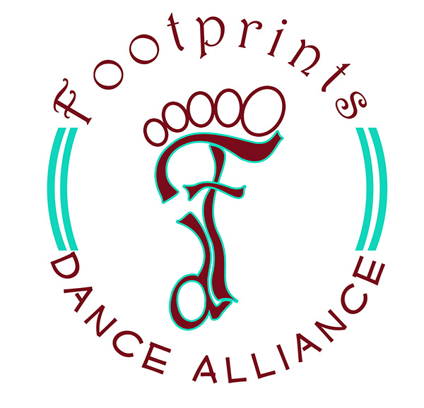
Fall Semester
2026

Tuition at Footprints Dance Alliance for 2026-2027

In order to simplify our families’ financial responsibilities and help with family budgets here at Footprints Dance Alliance, we are going to an ALL INCLUSIVE PRICING system! This way, we will decrease the number of times you have to dig into your wallet! Sounds great, right?

Like many studio programs, we are combining all the costs up front so that you have ONE PRICE per month that will include:
- All Weekly Dance Lessons
- Christmas Production Fee (Fall Semester)
- Christmas Costume (Fall Semester)
- Spring Costume (Spring Semester)
- Spring Production Fee (Spring Semester)
- Administrative Fees
All students will be required to enroll in our Auto-Pay Program when they register for their Fall classes. This is a very secure system and allows for easy and fast processing without the need for you to pay convenience fees and surcharges. All accounts will be deducted on the 1st of every month. Should your dancer decide that they no longer want to participate in dance classes, you can easily suspend Auto-Pay payments through your Parent Portal. We ask that you give us a 30 day withdrawal notice via email to Admin@footprintsga.com to let us know that you wish to suspend lessons. Please note that there will be a $35 Decline Fee should your credit or debit card on file be declined.
We hope this allows you to better budget for dance, in that you are no longer having to come up with additional fees during the “most expensive” times of the year such as Christmas, end of the school year activities and summer vacations. We understand that the end of semester productions, Spring and Fall, are optional. However, they are a very important aspect of a dance education. Therefore, there will not be any tuition deductions for electing not to participate in the Christmas and/or Spring Productions.

As always our outstanding Dream Team will be here to watch your child grow and blossom in their next year of dance! Many new improved progressions and programs will be in place! You will NOT want to miss it!! We look forward to serving you and your family in the 2023-2024 Dance Season!

- For Information on how to be considered for the 2026-2027 Footprints Dance Alliance Company please email Mrs. Bonnie at footprintsdancealliance@gmail.com.

2026-2027 ALL INCLUSIVE Tuition Rates:
Creative Movement $90 Per Month
One Hour Classes $105 Per Month
Less Than One Hour Classes $90 Per Month
Additional Classes/Siblings (One Hour) $95 Per Month
Additional Class/Siblings (Less than One Hour) $80 Per Month

Spring Semester:

August 10th-December 13th

Spring Production (Tentative Date)
- Sunday December 13th at St. Pius X Catholic High School

Footprints Dance Alliance
2026-2027 Class Descriptions

Dance Classes:

Creative Movement (Ages 2-3)
Imagine! Dream! Create! Your child will experience a new and exciting way to dance through themed lesson plans, hands on activities and creative play! Come imagine with us!

Prep I (Ages 4-5)
This is the first steps of a taking a true dance technique class. The class will use innovative and imaginative lesson plans to cultivate a love for dance! The class is 30 minutes of Ballet and 30 minutes of Tap.

Prep II (Ages 6-7)
This is a Ballet, Tap and Jazz Combination class. This class is a continuation from Prep I. This class is 20 minutes of Ballet Technique, 20 minutes of Tap Technique, and 20 minutes of Jazz Technique.

Pre-Company Prep (Ages 5-9)
This class is designed for dancers that wish to be considered for the Footprints Dance Alliance 2027-2028 Company. The class will consist of 30 minutes of Ballet, 30 Minutes of Tap and 30 minutes of Jazz. This class requires an instructor recommendation.

Ballet I (Ages 9-11)
*This class will audition for Production Pieces in the Christmas and Spring Productions
Ballet I introduces and reinforces the fundamentals of classical ballet for beginner to intermediate dancers. Students will focus on proper placement, basic terminology, and foundational technique while developing posture, balance, and coordination. This class provides a structured and nurturing environment that encourages discipline, grace, and a love for ballet.

Ballet II (Ages 12-18)
*This class will audition for Production Pieces in the Christmas and Spring Productions
Ballet II is designed for intermediate to advanced dancers with a strong understanding of ballet fundamentals. This class emphasizes refining technique, increasing strength and flexibility, and executing more advanced barre and center work. Dancers will continue developing artistry, control, and discipline as they grow in their technical abilities.

Jazz I (Ages 9-11)
*This class will audition for Production Pieces in the Christmas and Spring Productions
Jazz I is an energetic and engaging class designed for beginner to intermediate dancers. Students will learn and strengthen foundational jazz technique including turns, kicks, jumps, and stylized movement while building coordination, flexibility, and musicality. This class focuses on proper technique in a fun and encouraging environment, helping dancers grow in confidence and performance quality.

Jazz II (Ages 12-18)
*This class will audition for Production Pieces in the Christmas and Spring Productions
Jazz II is designed for intermediate to advanced dancers who are ready to elevate their technique and artistry. Dancers will focus on more complex combinations, precision, strength, and flexibility. This class challenges students to grow in musicality, expression, and performance presence while continuing to refine strong technical execution.

Tap I (Ages 9-11)
*This class will audition for Production Pieces in the Christmas and Spring Productions
Tap I is a beginner to intermediate class focused on building a strong foundation in tap technique and rhythm. Dancers will learn and refine basic steps, timing, and coordination while exploring rhythmic patterns and sound clarity. This class encourages confidence, musicality, and precision in a fun and supportive setting.

Tap II (Ages 12-18)
*This class will audition for Production Pieces in the Christmas and Spring Productions
Tap II is designed for intermediate to advanced dancers ready to take their tap skills to the next level. This class focuses on intricate rhythms, faster footwork, and greater precision. Dancers will continue developing musicality, clarity of sound, and performance quality while being challenged to grow in both technique and confidence.

Acting/Musical Theater Classes:

Broadway Buddies (Ages 4-7)
This high-energy, confidence-building class introduces young performers to the exciting world of musical theatre! Through fun games, creative movement, and age-appropriate songs and scenes, students will explore the three key elements of musical theatre: singing, dancing, and acting. Students will grow their confidence, teamwork, and stage presence while using their imagination and having a blast. No previous experience is required—just a willingness to try, play, and shine! The class encourages creativity in a supportive, positive environment where every child gets a chance to be a star.

Acting I (Ages 8-11)
*This class DOES NOT PARTICIPATE in Spring or Christmas Productions
Where imagination takes center stage! Lights, imagination, action! Acting I is the perfect place for students to step into the world of performance and storytelling. Through games, improv, and creative exercises, students will learn how to express emotions, build characters, and grow their confidence on stage. This class is all about having fun, trying new things, and discovering the joy of bringing stories to life!

Acting II (Ages 12-18)
*This class DOES NOT PARTICIPATE in Spring or Christmas Productions
Stronger characters. Bolder performances. Ready to take the stage with confidence? Acting II helps students level up their performance skills by diving deeper into character development, scene work, and emotional connection. Students will explore more advanced acting techniques while building boldness and authenticity in their performances. This class is perfect for students who love to perform and are ready to shine even brighter!

Musical Theater I (Ages 8-11)
*This class will audition for Production Pieces in the Christmas and Spring Productions
Step into the spotlight and shine! Sing, dance, act—repeat! Musical Theater I is a high-energy class where students get to experience the magic of Broadway. Students will learn how to tell stories through song, movement, and expression while building confidence and stage presence. With fun routines and engaging activities, this class is perfect for students who love to perform and have a blast doing it!

Musical Theater II (Ages 12-18)
*This class will audition for Production Pieces in the Christmas and Spring Productions
Triple-threat training for the stage! Bring the spotlight with you! Musical Theater II helps students grow into confident triple-threat performers by combining strong acting, singing, and movement skills. Students will take on more challenging choreography and storytelling while learning how to fully connect to their performances. This class is all about energy, expression, and shining on stage!

On Camera I (Ages 8-11)
*This class DOES NOT PARTICIPATE in Spring or Christmas Productions
Find your confidence in front of the camera! Lights, camera, confidence! On Camera I introduces students to the exciting world of acting for film and TV. Students will learn how to perform naturally on camera, understand basic filming techniques, and practice fun on-screen exercises. Watching their own recordings helps students grow in confidence and discover how to truly connect through the lens!

On Camera II (Ages 12-18)
*This class DOES NOT PARTICIPATE in Spring or Christmas Productions
Camera-ready and confident! Take your on-screen presence to the next level! On Camera II is designed for students ready to sharpen their skills with more advanced scene work, audition techniques, and self-taping practice. Students will learn how to deliver confident, polished performances while gaining valuable tools used in the professional industry. It’s all about helping students feel comfortable, capable, and camera-ready!

Footprints Dance Alliance
Recreational Classes
Fall 2026

Please note that all classes with less than 5 students are subject to cancelation

Creative Movement (Ages 2-3)
Pre-Ballet/Pre-Tap Combo
Monday | 4:00-4:45
Tuesday | 5:00-5:45

Prep I (Ages 4-5)
Ballet/Tap Combo
Monday | 4:45-5:45
Monday | 5:45-6:45

Prep II (Ages 6-7)
Ballet/Tap/Jazz Combo
Monday | 4:30-5:30
Tuesday | 5:45-6:45

Pre-Company Combo
Ballet/Tap/Jazz Combo
*Students who want to be considered for the 2027-2028 Footprints Company*
* Must Have Instructor Recommendation*
Pre-Company | Ages 5-7 | Monday | 4:30-5:30

Broadway Buddies ( Ages 4-7)
Acting/Singing/Dancing for the Stage
Broadway Buddies | Monday | 5:45-6:30

Musical Theater (Acting/Singing for the Stage)
MT I | Ages 8-11 | Wednesday | 5:15-6:00
MT II | Ages 12-18 | Wednesday | 6:00-6:45

Acting and Improv (Acting for the Stage)
Acting/Improv I | Ages 8-11 | Monday | 6:30-7:30
Acting/Improv II | Ages 12-18 | Monday | 7:30-8:30

On Camera (Acting for Film/TV)
On Camera I | Ages 8-11 | Wednesday | 4:30-5:15
On Camera II | Ages 12-18 | Wednesday | 6:45-7:30
Jazz
Jazz I | Ages 8-11 | Monday | 5:30-6:30
Jazz II | Ages 12-18 | Monday | 6:30-7:30

Tap
Tap I | Ages 8-11 | Thursday | 5:30-6:30
Tap II | Ages 12-18 | Thursday | 6:30-7:30

Ballet
Ballet I | Ages 8-11 | Tuesday | 6:00-7:00
Ballet II | Ages 12-18 | Tuesday | 7:00-8:30

Footprints Dance Alliance
Dress Code
Creative Movement
Any color leotard and/or dance dress
Pink Tights
Pink Leather Ballet Shoes
Tan Mary Jane Tap Shoes (Starting in January)

Prep I
Any color leotard and/or dance dress
Pink Tights
Pink Leather Ballet Shoes
Tan Mary Jane Tap Shoes

Prep II
Any color leotard and/or dance dress
Pink Tights
Pink Leather Ballet Shoes
Tan Marty Jane Tap Shoes
Tan Slip On Jazz Shoes (no laces)

Pre-Company Prep
Any color leotard and/or dance dress
Pink Tights
Pink Leather Ballet Shoes
Tan Marty Jane Tap Shoes
Tan Slip On Jazz Shoes (no laces)

Musical Theater/Broadway Buddies
Any Color Leotard
Any Color Dance Booty Shorts (Optional)
Tan Tights
Tan Slip On Jazz Shoes

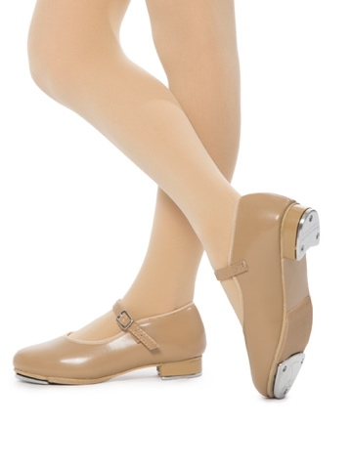
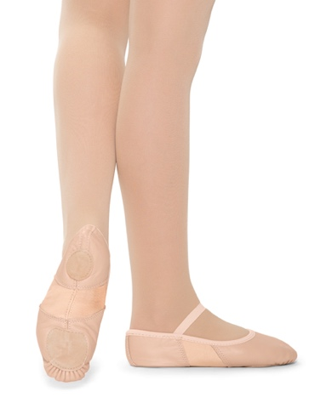

Pink Leather Ballet Shoes Tan Mary Jane Style Tap Shoes

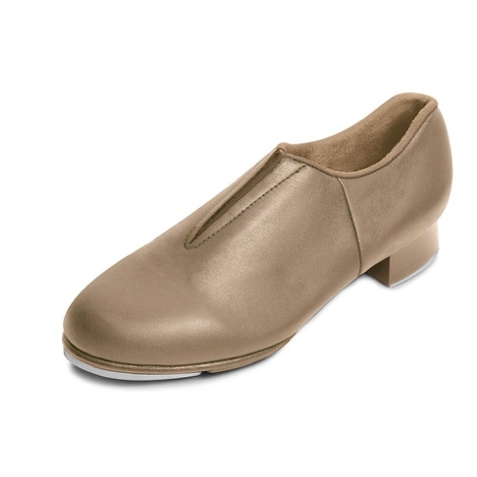
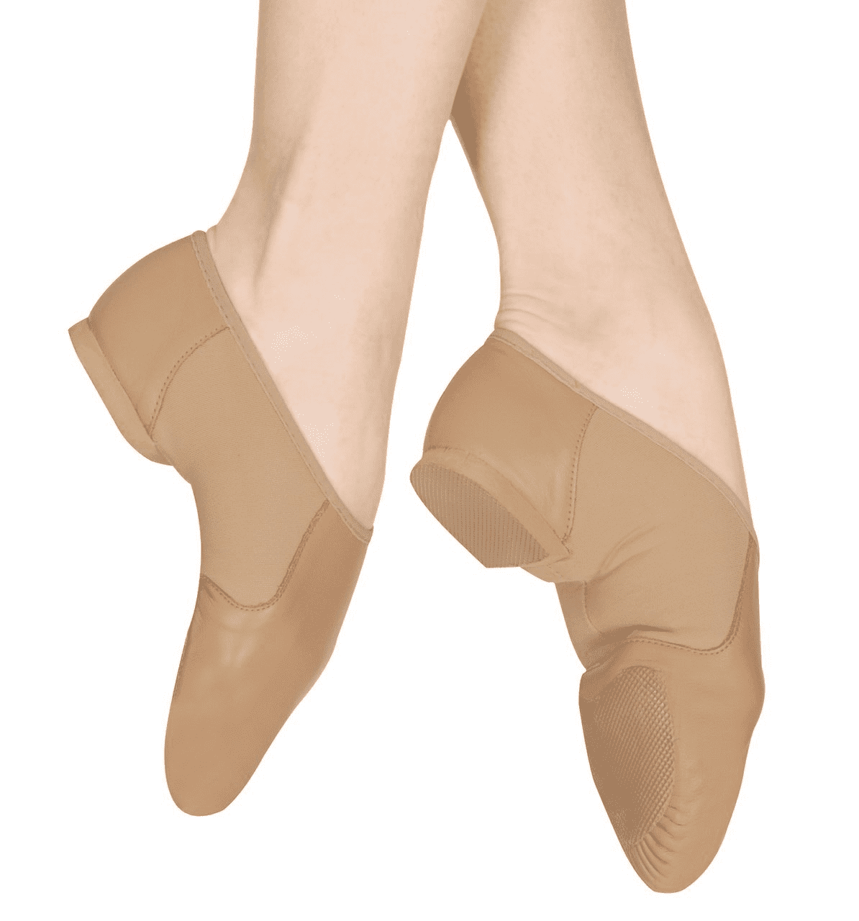

Tan Slip On Jazz Shoes Tan Slip On Tap Shoes

Footprints Dance Alliance 2026-2027
Studio Calendar

*Studio Closure Dates listed on this calendar are not included in your monthly tuition*

August 10th First Day Of Dance Class

September 7th Closed for Labor Day

September 28th -30th Closed for Fall Break

November 23rd-27th Closed for Thanksgiving

December 7th-13th Production Week
(No Regular Classes)
December 13th Christmas Production (Tentative)

December 14th – January 3rd Closed for Christmas Break

January 4th Classes Resume

February 12th-16th Closed for Mid-Winter Break

April 5th-9th Closed for Spring Break

April 26th-30th Production Week
(No Regular Classes)

May 2nd Spring Production (Tentative)

*Severe Weather Policy
We tend to follow the Forsyth County School System’s lead when it comes to weather closures. However, there may times we need to close early or completely in order to keep our faculty members who drive long distances safe. We announce all weather related closures through email and on the Footprints Facebook page. Make Up classes for these closures will be announced in the “closure email.”

